1. Given a CustomerID, name and email, create a new Customer record.

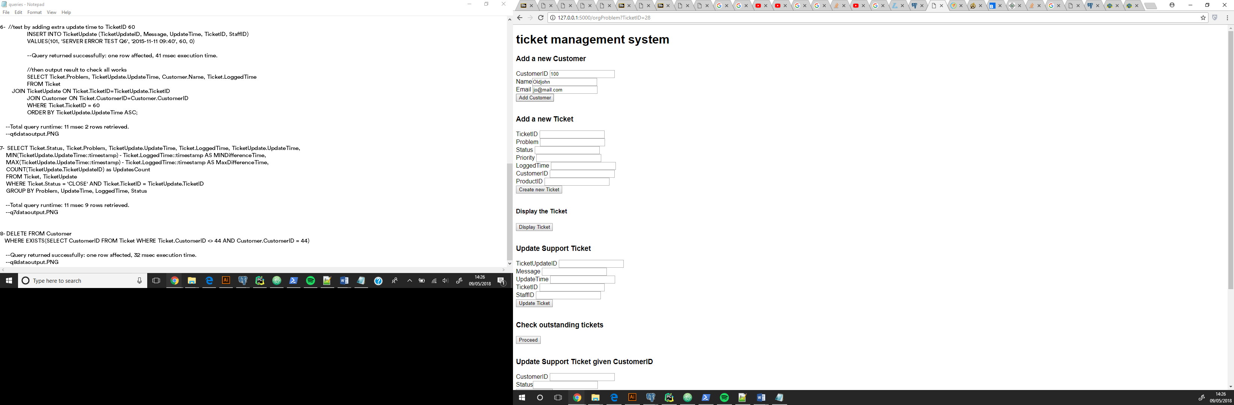

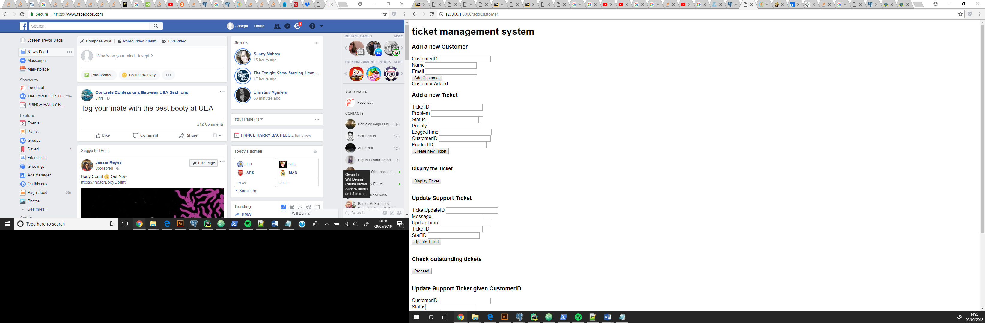

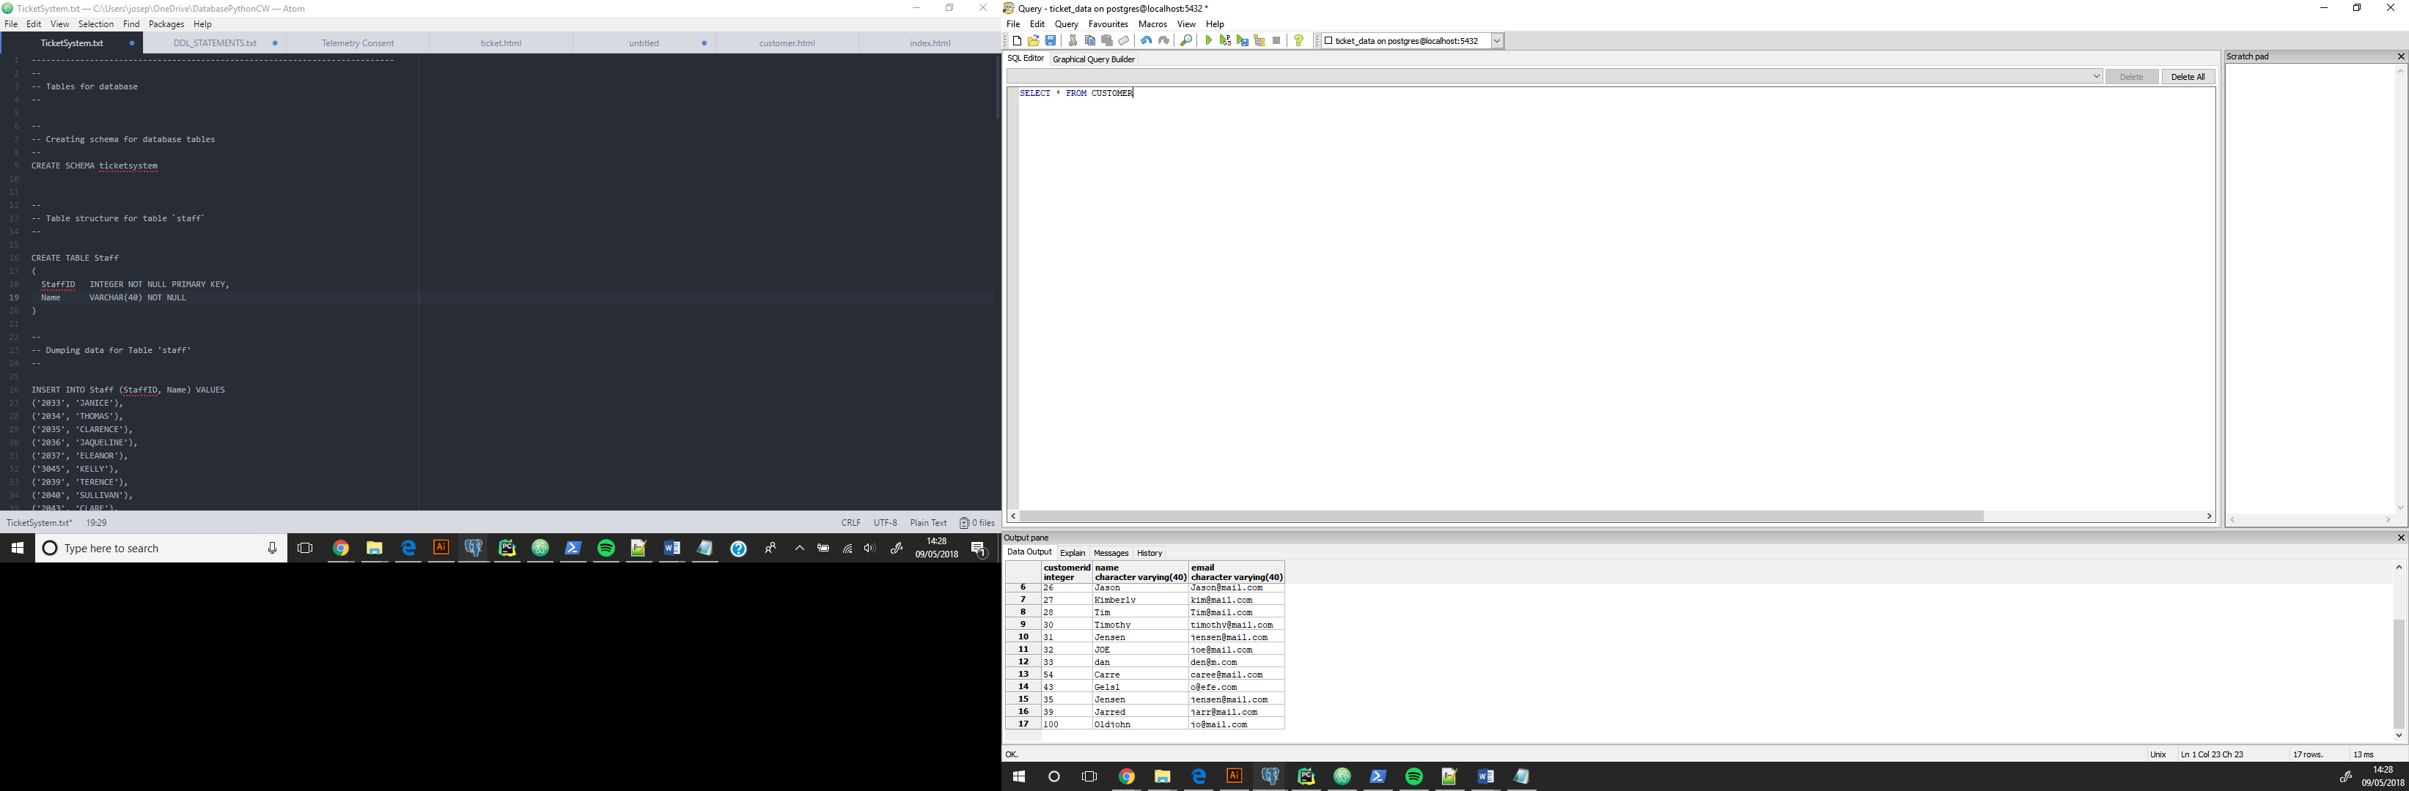

1. Create a new support ticket for a customer with respect to a given product. The application should display details of the ticket as confirmation.

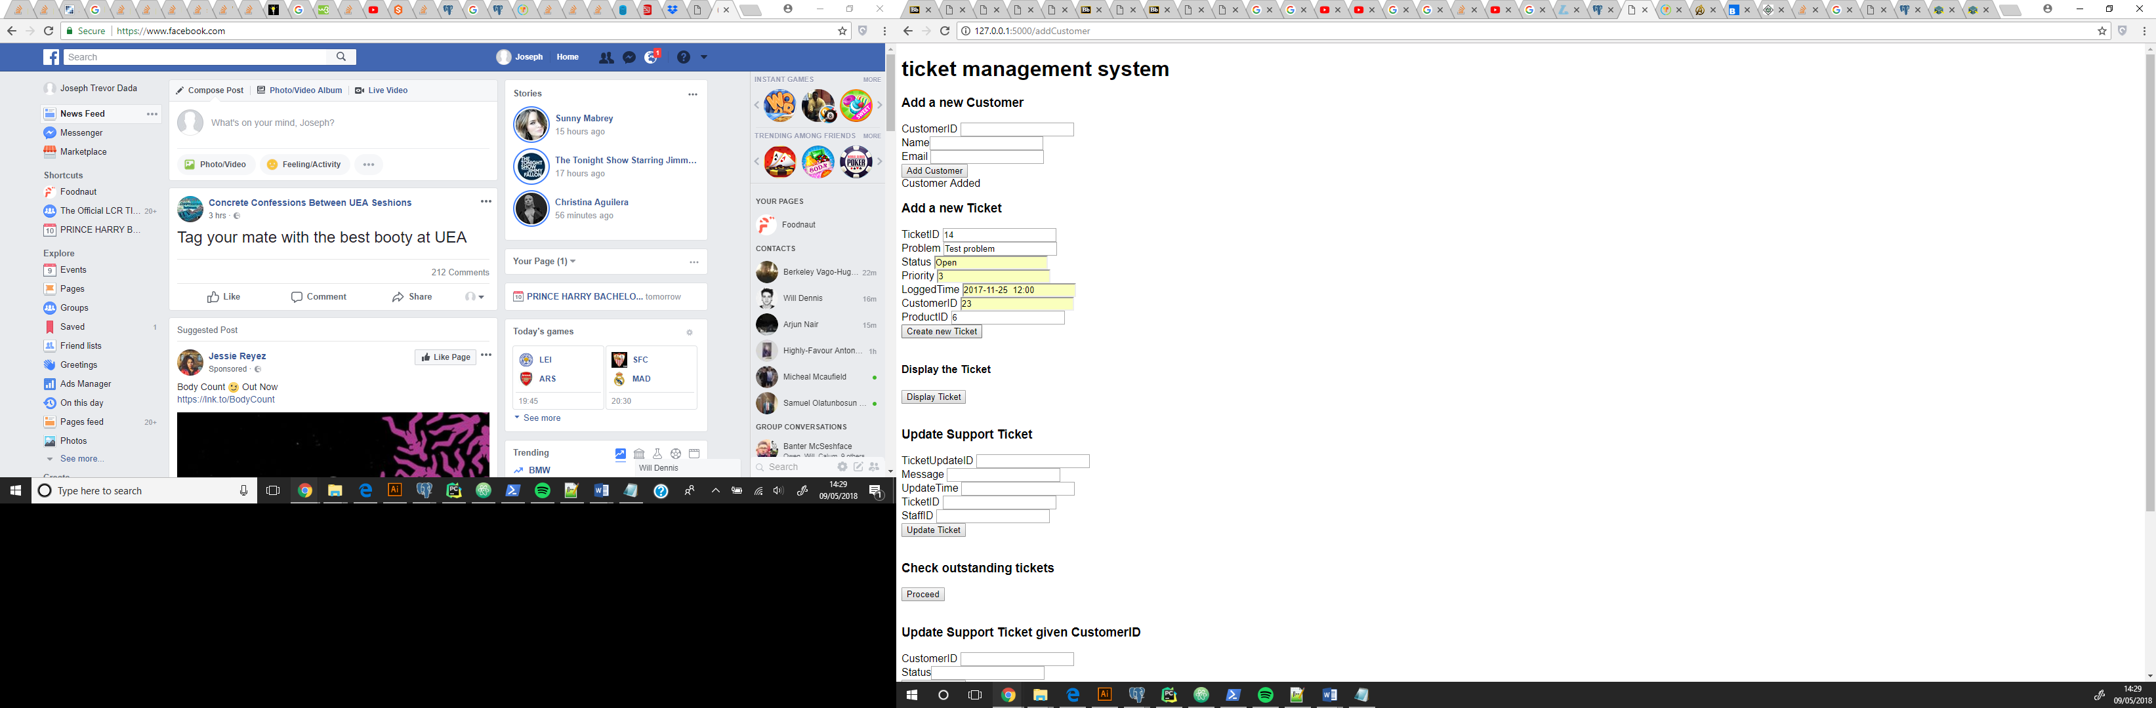

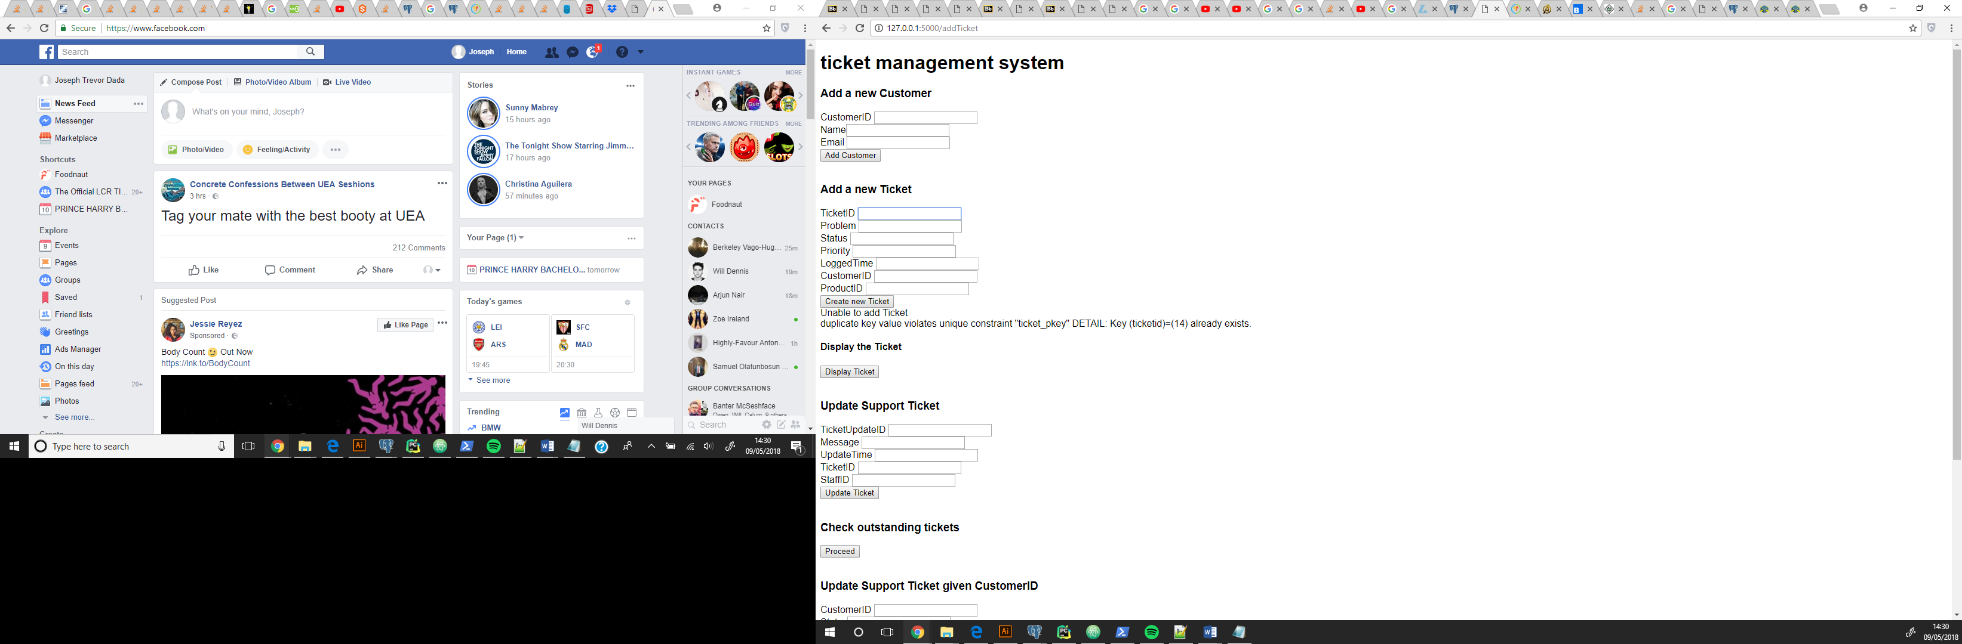

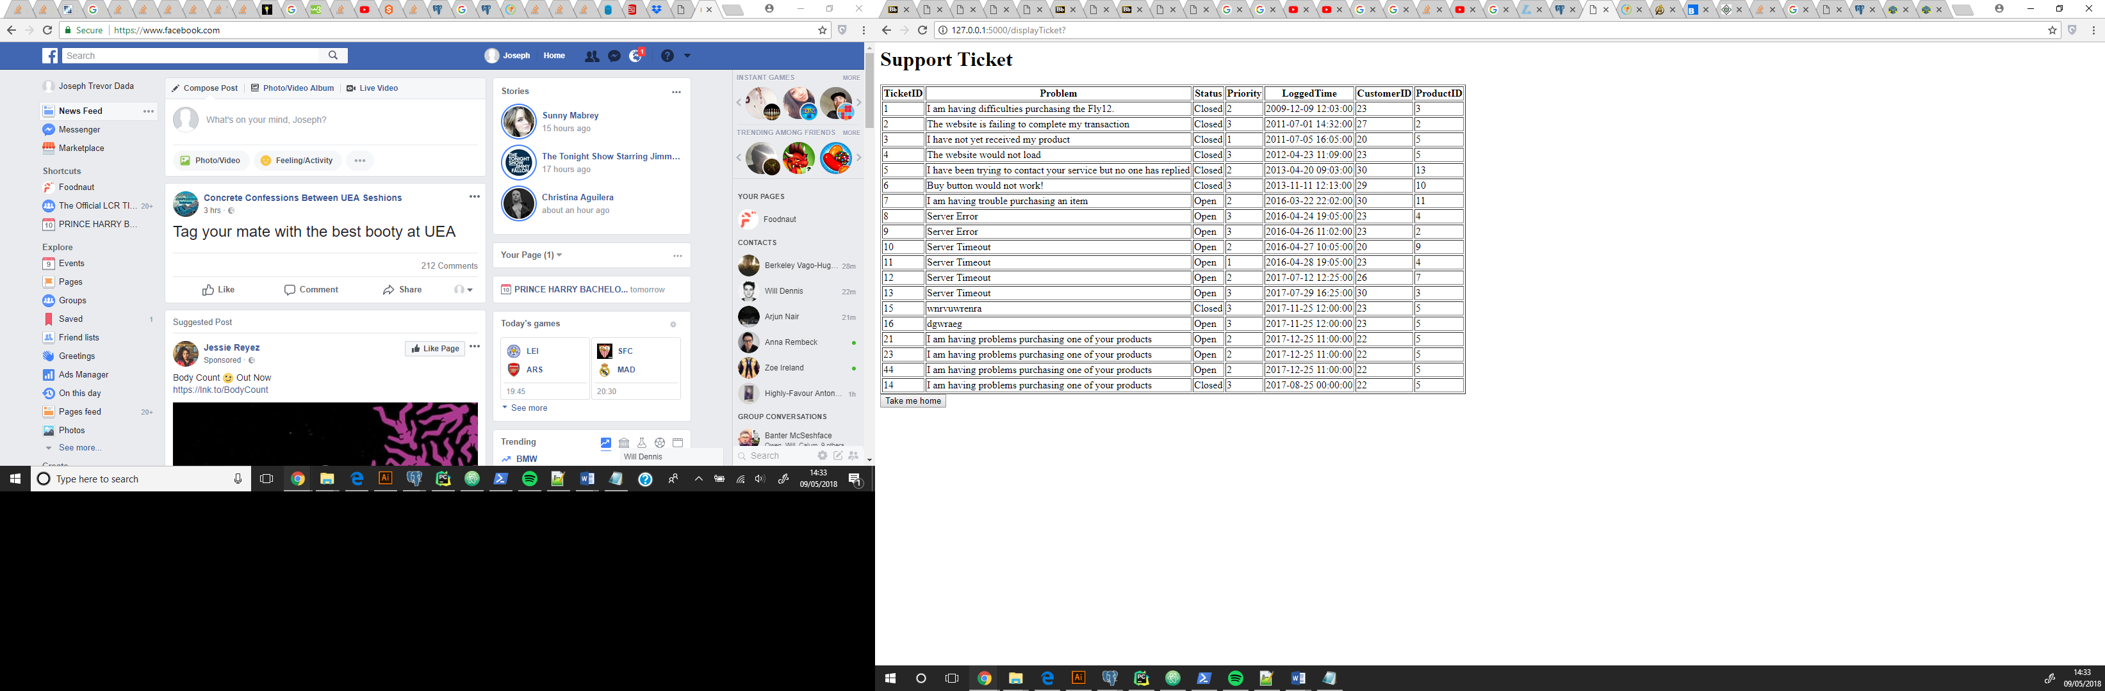

1. Add an update to the support ticket from a given staff member
2. List all outstanding (i.e. open) support tickets along with the time of the last update (if applicable).

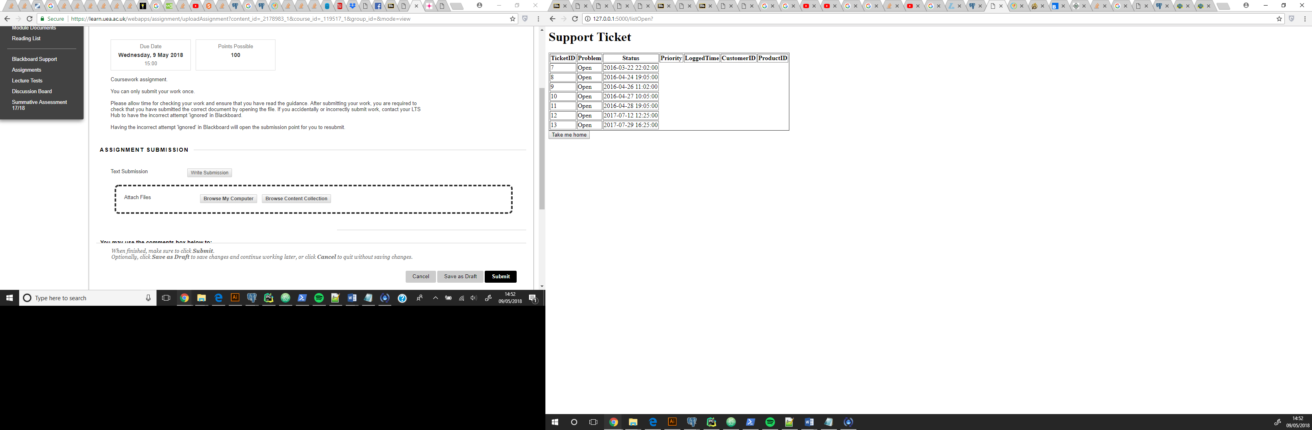

1. Given a ticketID, set the status of a support ticket to closed.

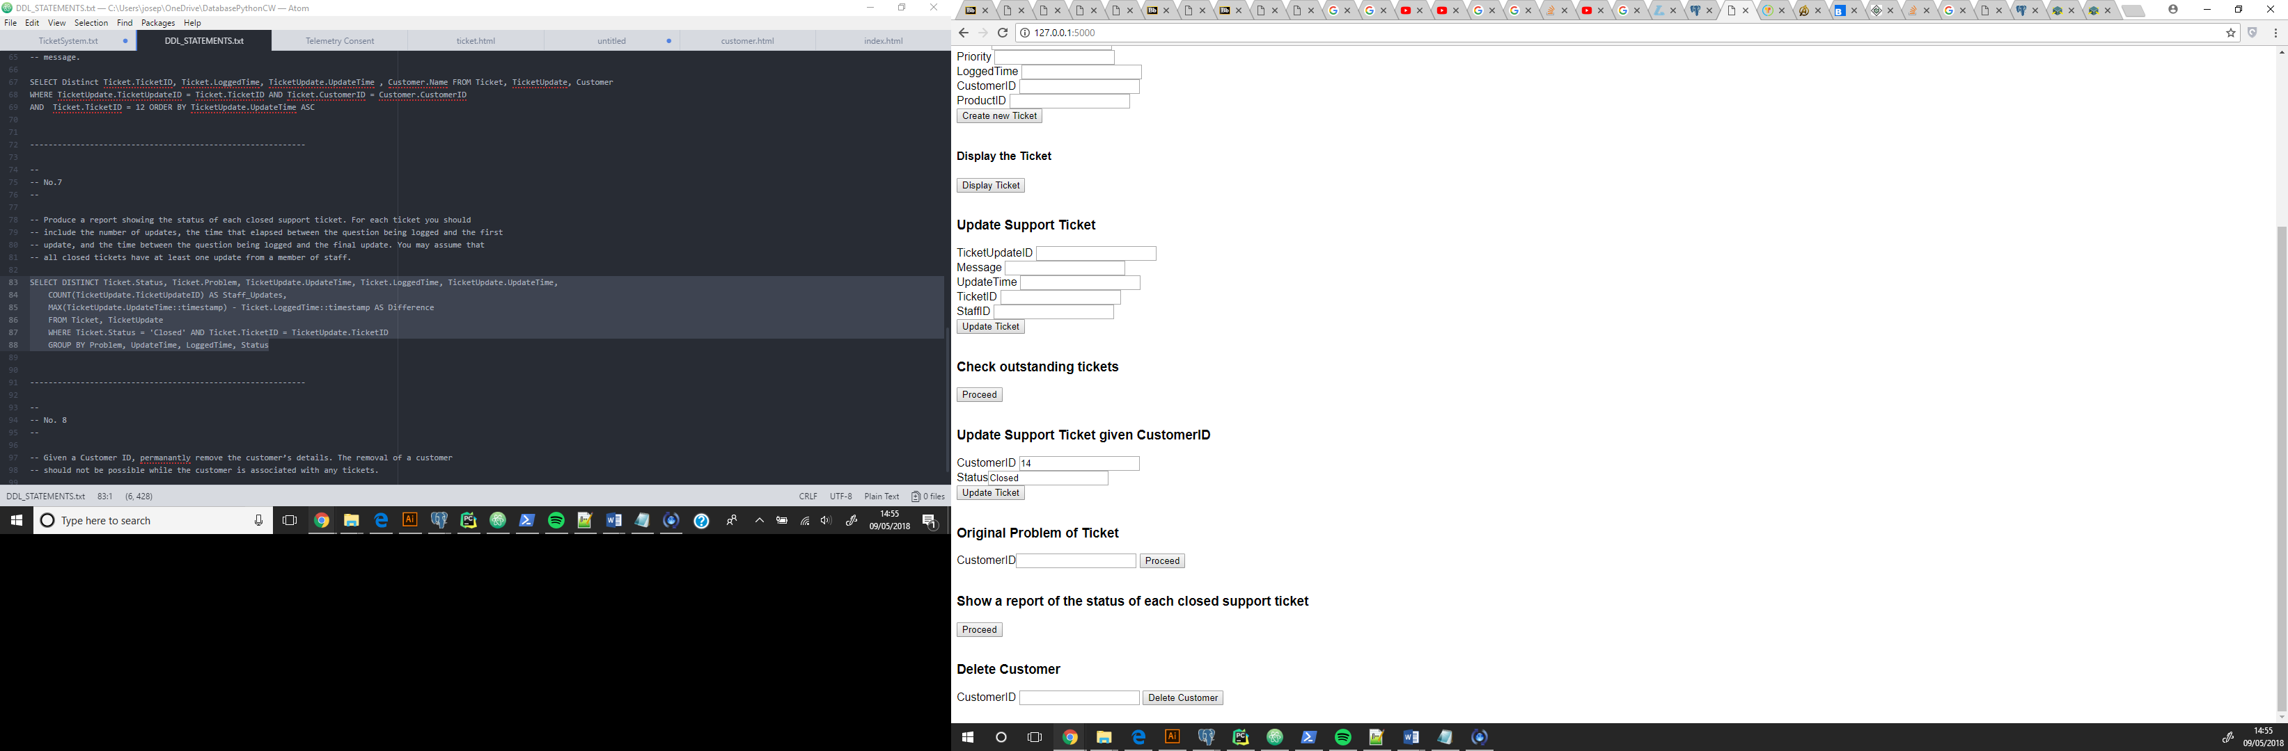

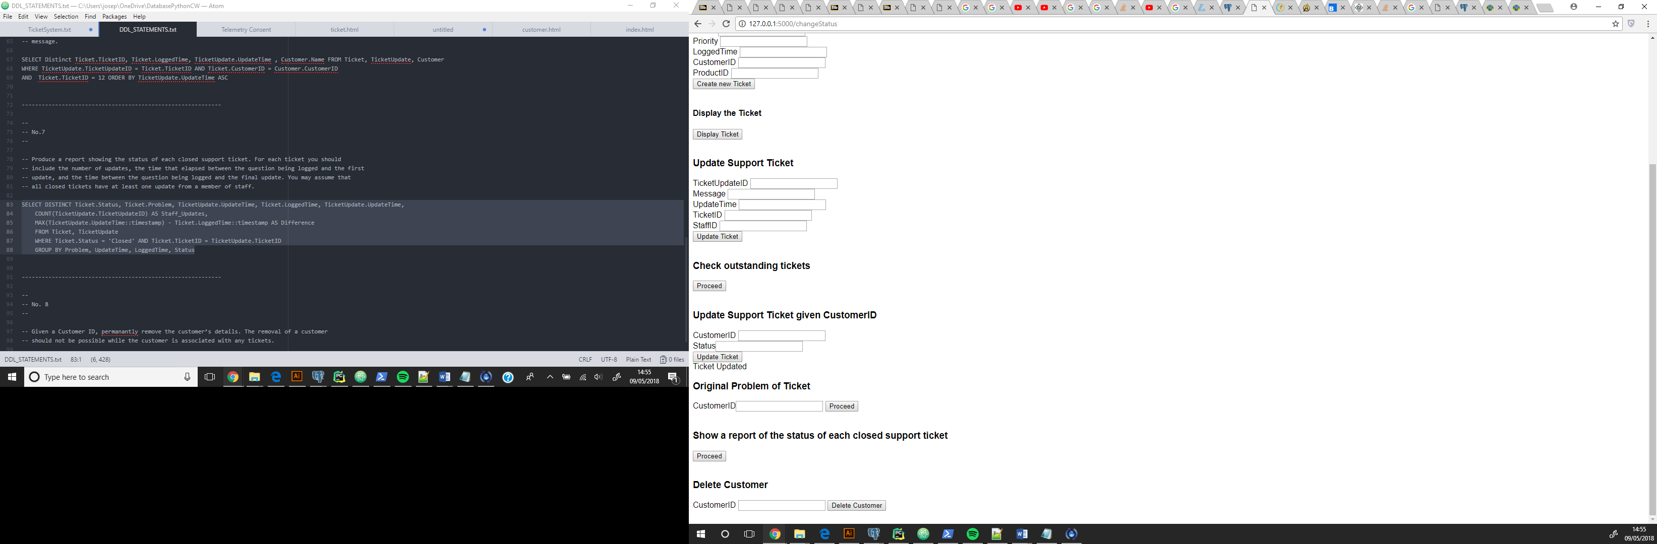

6. Given a ticketID, list the original problem as the question along with all updates in chronological order. For each line, include the time of the message and the name of the person who authored the message.

7. Produce a report showing the status of each closed support ticket. For each ticket you should include the number of updates, the time that elapsed between the question being logged and the first update, and the time between the question being logged and the final update. You may assume that all closed tickets have at least one update from a member of staff.

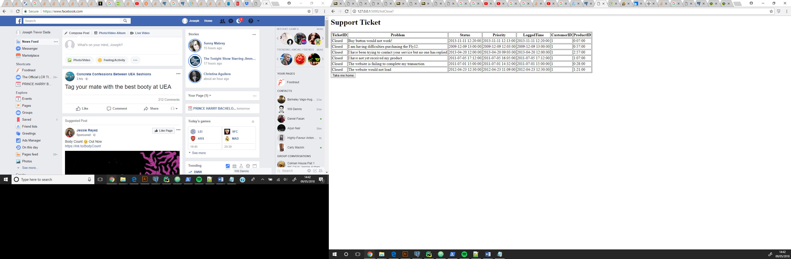

8. Given a Customer ID, permanantly remove the customer’s details. The removal of a customer should not be possible while the customer is associated with any tickets.

